COMP 361 Computer Networks

Spring Semester 2002
Midterm Examination
Date: April 9, 2002 Time: 4:30 pm – 5:50 pm (in class)

Name:_____________________ Student ID: ________________Email:__________________

Instructions
- Please write your name, student ID and email address on this page.
- Please answer all questions within the space provided on the examination paper. You may use back of the pages for your rough work. Please be concise, and this is NOT an essay contest.
- This paper consists of 4 questions and 7 pages.
- Please read each question very carefully and answer the questions clearly to the point. Make sure your answers are neatly written, legible, and readable.
- Show all the steps used in deriving your answer, wherever appropriate.

Question | Points | Score
1 | 20
2 | 25
3 | 25
4 | 30
Total | 100

- (20 points) Answer the following true/false questions by circling either T or F.
  - There is no need for buffering in a circuit-switched network T F
  - Cable modems give you dedicated access to the Internet. T F
  - Transport services provide in-order segment delivery. T F
  - During the TCP slow start phase, the window size is increased by one per RTT. T F
  - UDP provides bandwidth guarantee, thus is often used by real-time applications. T F
  - Ethernet can be either shared or dedicated. T F
  - A persistent HTTP protocol always results in smaller delay than a non-persistent
HTTP protocol. T F
  - A Go-back-N protocol can achieve better performance than a Selective Repeat
protocol, so TCP uses the go-back-N protocol not the Selective Repeat protocol. T F
  - The delay in packet-switched network includes node processing, queuing,
transmission time and propagation delay. T F
  - Root domain name server can resolve all names to IP address mapping. T F

- (25 points) Suppose that a sender with a files of size M bits to be transmitted to a receiver across K-1 routers (i.e., K-hops, see diagram below) in a packet-switched network in a series of packets. Each packet contains p data bits and h header bits, with M >> p+h. All the link speed (bit rate) is b bits per second.

- Assume that the propagation delay between each hop is d, there is no error and ignore all processing and queuing delay, what is the total end-to-end delay T in order to transmit the file (15 points)
Answer:
Suppose $m=\left\lceil \frac{M}{p}\right\rceil$ be the number of packets, $n=(M\text{mod}p)$be the last packet size.
The last packet waits for $(m−1)\frac{p+h}{b}$ time before it can be transmitted, and it takes $\frac{n+h}{b}$ transmission time in the source node.
When this last packet reaches the intermediate node, it cannot be transmitted immediately as $n<p$. The waiting time is $\frac{p−n}{b}$, and its transmission time is $\frac{n+h}{b}$, so the total time at each intermediate node is $\frac{p+h}{b}$.
There are total $K−1$ intermediate nodes, so the overall end-to-end delay is
$$T=(m−1)\frac{p+h}{b}+\frac{n+h}{b}+(K−1)\frac{p+h}{b}+\text{Kd}=(K+m−2)\frac{p+h}{b}+\frac{n+h}{b}+\text{Kd}$$
Alternatively:
The first packet will arrive at the destination at $K\frac{p+h}{b}+\text{Kd}$. Then the last packet needs to wait $\frac{n+h}{b}+(m−2)\frac{p+h}{b}$ time, (simply the transmission time of the remaining packets).
So we get essentially the same answer:
$T=K\frac{p+h}{b}+\text{Kd}+\frac{n+h}{b}+(m−2)\frac{p+h}{b}=(K+m−2)\frac{p+h}{b}+\frac{n+h}{b}+\text{Kd}$
- Now suppose we ignore the propagation delay, and M=mp, what is the value of p (data packet size) that minimizes the total end-to-end delay (10 points)
Answer:
So the total end-to-end delay is
$f(p)=(K+m−1)\frac{(p+h)}{b}=\frac{1}{b}[\frac{M}{p}+(K−1)](p+h)=\frac{M}{b}+\frac{\text{Mh}}{b}p^{−1}+\frac{K−1}{b}p+\frac{(K−1)h}{b}$.
Take the derivative w.r.t. p, and set it to zero, $f'(p)=−\frac{\text{Mh}}{b}p^{−2}+\frac{K−1}{b}=0$ .
We can obtain p that immunizes the delay: $p={\left(\frac{K−1}{\text{Mh}}\right)}^{{−1}/2}=\sqrt{\frac{\text{Mh}}{K−1}}$.
- (25 points) Transport Protocol
- The following is a simple view of the state transition diagrams for both client and server in TCP. Please illustrate the three-way hand-shaking protocol. (10 points)

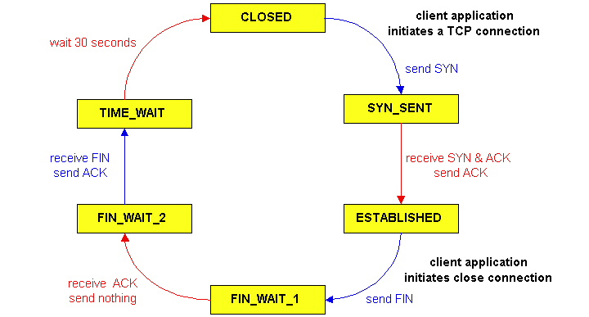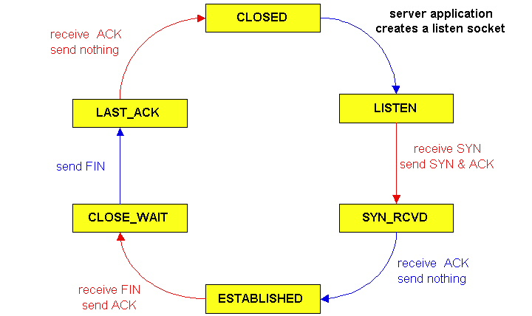

Answer:

client
Send SYN
server
Receive SYN, send SYN & ACK
Receive SYN & ACK, send ACK
ESTABLISHED
SYN_SENT
LISTEN
SYN_RCVD
ESTABLISHED

- The following is an instance of the Selectived Repeat protocol, please identify what goes wrong with this example, and how to resolve this (15 points)

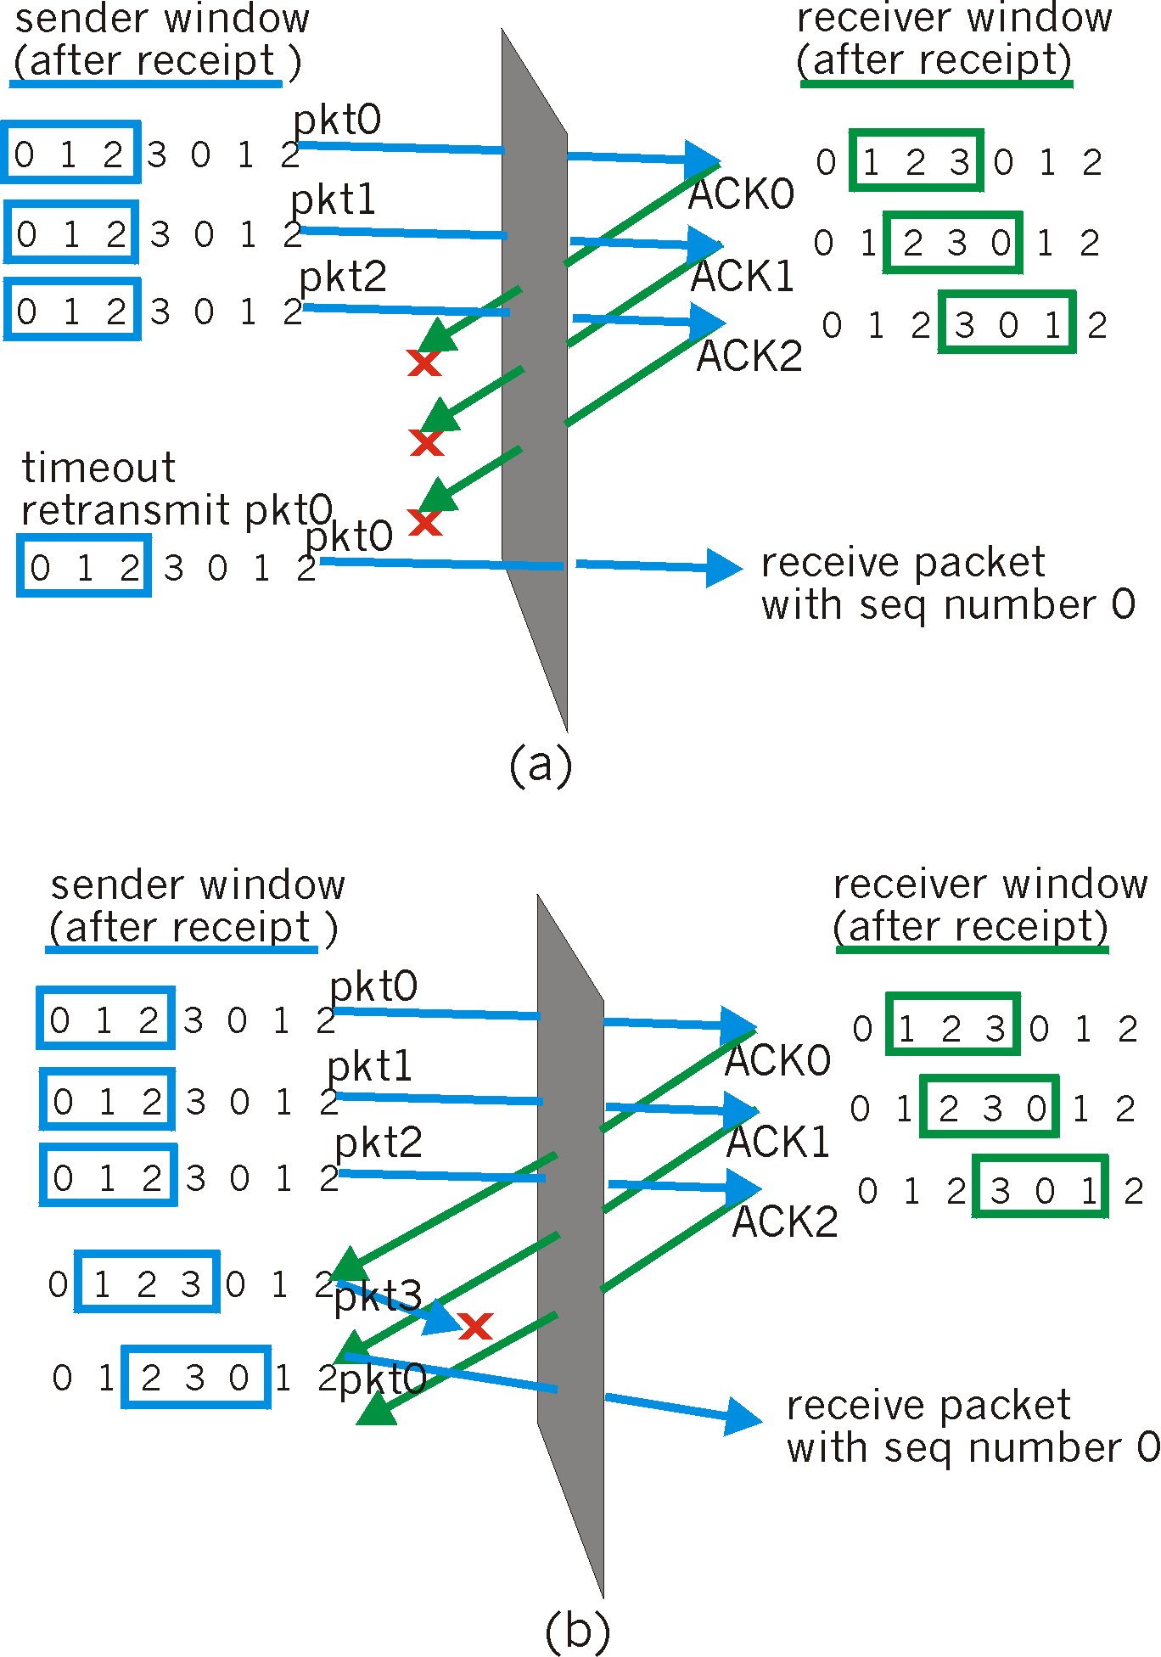
Answer:

The fundamental problem in this example is that receiver upon acknowledging the packet 0, 1 and 2, will treat the re-transmitted packet 0 as a new packet. This is caused by the fact that the sequence number is too small. In general, this can be resolved by ensuring that the sequence number space 2^{n} is at least twice of the window size K, i.e., 2^{n} > K.

- (30 points) Please briefly answer the following questions (Please be concise, and each answer preferably uses less than 3-44 sentences. 6 points for each question)
- Why is TCP congestion avoidance called AIMD (additive-increase, multiple-decrese)?

Answer:

TCP increaes its window size by 1 each RTT (and thus increases its transmission rate by an additive factor) when its network path is not congested, and decreases its window size by a factor of 2 each RTT when the path is congested. For this reasons, TCP is referred as an additive-increase, multiple-descrese (AIMD) algorithm.

- What are three main services that TCP provides?

Answer:
Relible tranmission, flow control and congestion control

- What is the main difference between SMTP and POP3?

Answer:

SMTP trasnfer messages from senders’ mail servers to the recipients’ mail servers, thus it is a server-to-server mail transfer protocol; while POP3 is a mail access protocol, which transfers messages between recipient’s mail server to the local machine of the recipient.

- Why do real-time applications such as IP phones (Voice over IP) use unreliable UDP instead of reliable TCP services?

Answer:

The real-time applications such as IP phones can telorate some degree of packet loss, so that the reliable transfer is not absolutely critical. Since there is no flow control nor congestion control in UDP, it has a higher chance of pumping more data into the network, thus has a higher chance of obtaining a sustained (minimum) bandwidth from the network, which is ususally required by real-time applications.

- Both Virtual Circuit network (e.g., ATM) and circuit-switched network (e.g., Telephone) require connection setup before the communication takes place, what is the main difference between them?

Answer:

Circuit-switched network provides absolute service guarantee by reserving the necessary resources along the connection; while virtual circuit network relies on the statistical multiplexing, thus the packets have to share and compete with packets that belong to other connections.

